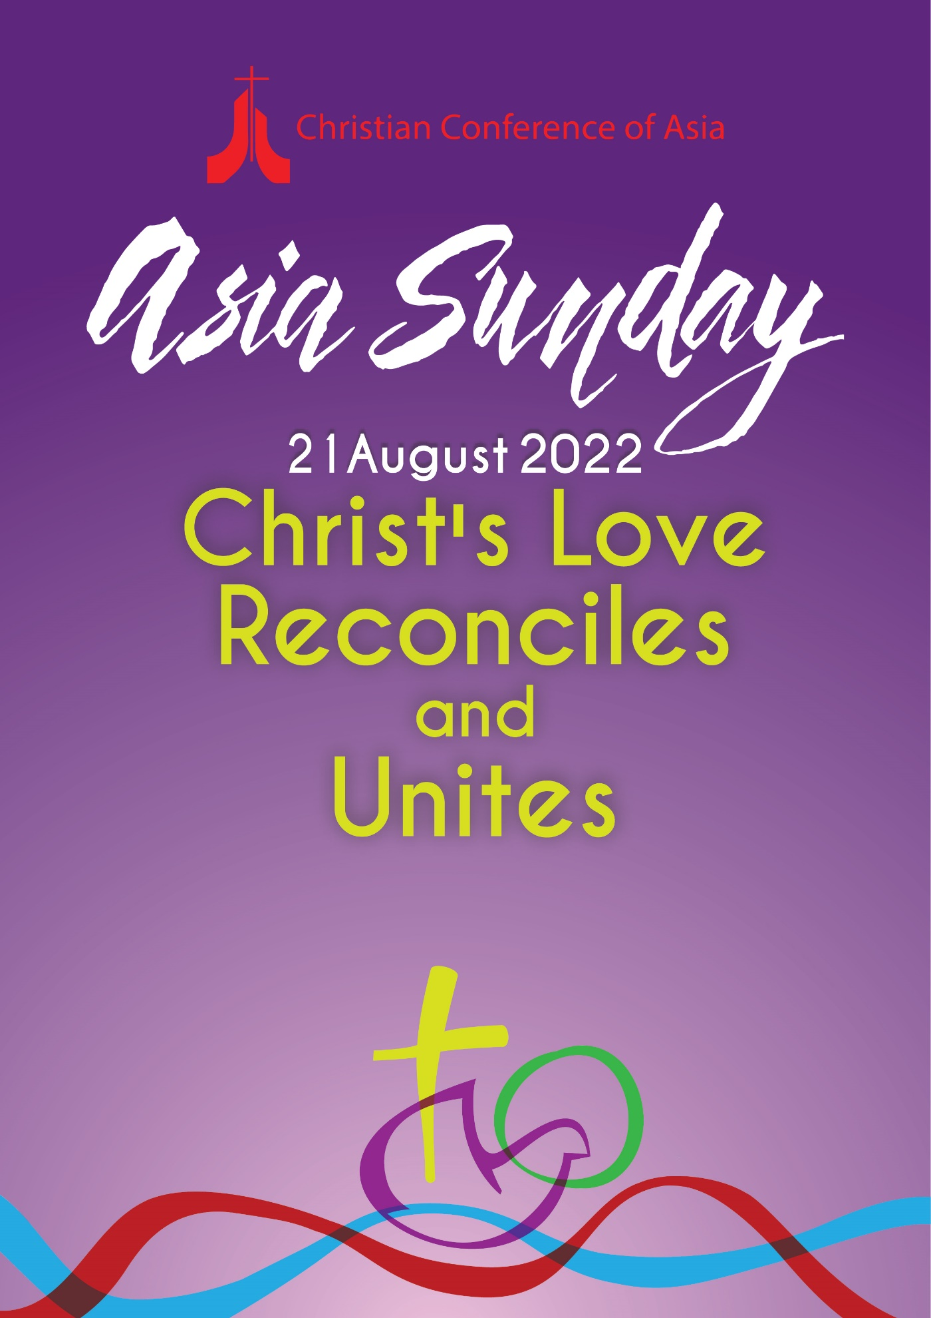
CCA General Secretary’s Introduction

Asia Sunday–2022
‘Christ’s love reconciles and unites’

The theme of the Asia Sunday–2022, ‘Christ’s love reconciles and unites’, is rooted in the Biblical verse, 2 Corinthians 5:18, and has also been derived from the 11th Assembly theme of the World Council of Churches (WCC), ‘Christ’s love moves the world to reconciliation and unity’. Reconciliation and unity are essential in healing this broken and wounded world and are imperative for God’s salvific mission. Our world today is fragmented by the scars of deep divisions and alienations, and we are called to emulate the sacrificial and self-emptying nature of Christ’s love that challenges us to partake in God’s mission of restoring and unifying the creation to himself.

Reconciliation is the act of God through Christ (2 Corinthians 5:19). Christ, the image of the invisible God, the firstborn over all creation, reconciled ‘things in heaven and on earth, visible and invisible, whether thrones or powers or rules or authorities’ (Colossians 1:15–20). Reconciliation is fulfilled through Christ’s love and finds its final expression in unity. God, who reconciled us to himself through Christ, gave us and committed to us the ministry and message of reconciliation.

Reconciliation and unity must be lived out through Christ’s self-sacrificing and self-emptying love. The ministry of Jesus exemplified reconciliation in different forms and dimensions. Through the cross, there was reconciliation between the divine and human. Through his actions, Christ was able to reconcile the differences between the poor and the rich, believers and non-believers, men and women, Jews and Gentiles, and so on. Jesus went towards those at the periphery of society and reinstated their dignity and worth. The sacrifice of Christ on the cross was for the redemption of the entire creation. Reconciliation and unity are not meant to be merely nominal or tokenish but must be seen as an affirmation of the will of God.

In the Asian context, our ministry of reconciliation and unity warrants us to address multiple issues of social, political, cultural, and religious realities such as the marginalisation, negation of peace with justice, religious extremism, human rights violations, the technological divide, and environmental degradation, and, of course, the aftermath of the COVID-19 pandemic. Christ, in his love, gathered up to himself suffering humanity. Christ continually identifies with the vulnerable, the fragile, and the broken, the ones who mediate the process of reconciliation when they call out for justice and the rectification of historical wrongs.

The suffering of creation moves God, and God’s love moves us. Christ’s work of reconciliation models a way to reconcile humans with humans, and humans with the rest of creation, through transforming any and all forms of exploitation. Unity cannot exist without our identifying ourselves with the other, without suffering with those who suffer. Unity, too, does not aim at homogenisation but is both a gift and obligation to sustain and nourish the values of love. We are called to unite ourselves to Jesus and be in a bond of communion (koinonia) and fellowship with each other, in a world that is otherwise deeply divided.

The Christian Conference of Asia (CCA) annually organises observance of Asia Sunday on the Sunday before Pentecost, which is an occasion for the CCA’s member churches and councils as well as other ecumenical partner organisations around the world to reflect upon a particular theme. This year, Asia Sunday is being organised in the run-up to the 11th Assembly of the WCC, which focuses its theme on “Christ’s love moves the world to reconciliation and unity”. CCA considers that the observance of the Asia Sunday–2022 on the eve of the WCC Assembly also will be an occasion to reflect on the forthcoming WCC Assembly theme from an Asian perspective. May the Asia Sunday–2022 be a clarion call for the member churches and councils of the CCA to metanoia, or a complete spiritual transformation, that empowers us to be more self-giving and self-emptying. This specially prepared liturgy for Asia Sunday is offered as a pathway to becoming inspired and becoming a community in Asia that authentically lives out the ministry of reconciliation and unity, which are the obligations of abiding in Christ’s love.

Mathews George Chunakara
General Secretary, Christian Conference of Asia

28 July 2022

Asia Sunday 2022
‘Christ’s Love Reconciles and Unites’

We Prepare our Hearts and Minds

Sound of the Flute (or any wind instrument)
Lighting the Candle
We Praise our Lord who Reconciles and Unites
Praise the Lord!
Praise our Lord in the heights above.
Praise the Lord, all angels,
Praise the Lord.
Praise the Lord, sun and moon; praise the Lord, all you shining stars.
Praise the Lord, you highest heavens and you waters above the skies.

Let them praise the name of the Lord, for at our Lord’s command they were created,
and the Lord established them forever and ever.

Praise the Lord from the earth, you great sea creatures and all ocean depths, lightning and hail, snow and clouds, stormy winds that do our Lord’s bidding, you mountains and all hills, fruit trees and all cedars, wild animals and all cattle, small creatures and flying birds, kings of the earth and all nations, you princes and all rulers on earth, young men and women, old men and children.

Let them praise the name of the Lord.
And our Lord has raised up for the people a horn, the praise of all faithful servants, of Israel,
the people close to the heart of our Lord.
Praise the Lord. (based on Psalm 148)

♫ Sing the Lord a New Song
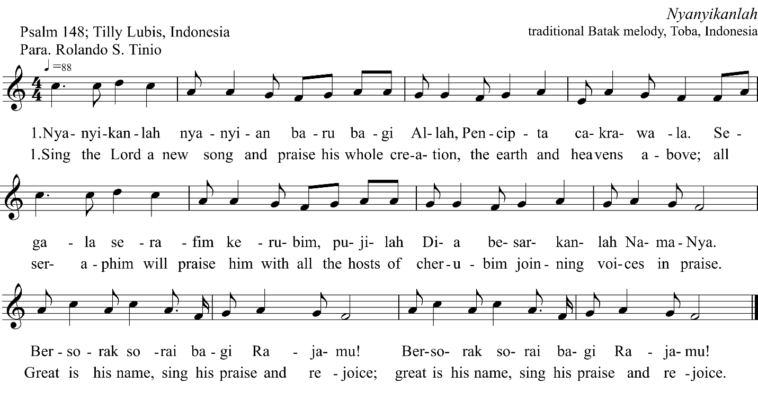
Our God, loving Creator,
You fashioned us from clay and breathed life into us.
Yet in this pilgrimage of life, we have broken Your trust in us and have embraced divisions due to our hunger for power.

Lord in your mercy, give us grace to reconcile and nurture unity among ourselves.

Loving God, it is You who has fashioned us in a variety of languages, cultures, and races. Do not let this diversity divide us. But help us to welcome the gifts we can receive from each other. Your Spirit fills us with hope and lights the path to fullness of life.
Hear us! As we cry out to you, uncertain, confused, and afraid.

Lord in your mercy, give us grace to reconcile and nurture unity among ourselves.

In your mercy, God,
Grant us the strength to rebuild when all seems lost.

We have been drawn together by one baptism into one faith,
Serving one Lord and Savior. Do not let us tear away from one another through divisions, hatred, and power politics. Help us to reflect on the peace of Your nature and embrace our differences.

Lord in Your mercy, give us grace to reconcile and nurture unity among ourselves.

Sound of the Bell or Chime or Ching

(Prayer in Silence)

Prayer of Confession
Out of the depths, we cry to you, O Lord! O Lord, hear our voice!
Let your ears be attentive to the voice of our pleas for mercy!
If you, O Lord, should mark iniquities, who could stand?
But with you, there is forgiveness, that you may be feared.
We wait for the Lord, our soul waits, and in God’s word we hope; our soul waits for the Lord more than watchmen for the morning.

O Israel, hope in the Lord! For with the Lord, there is steadfast love, and with God is plentiful redemption.
And God will redeem Israel from all iniquities. (based on Psalm 130)
Help us to reconcile, trust, and love each other.
May our love for you grow, so that we might rely on you, and be more generous with all you have given to us.

♫ “Ampo sa Paghinulsol” (Prayer of Repentance)

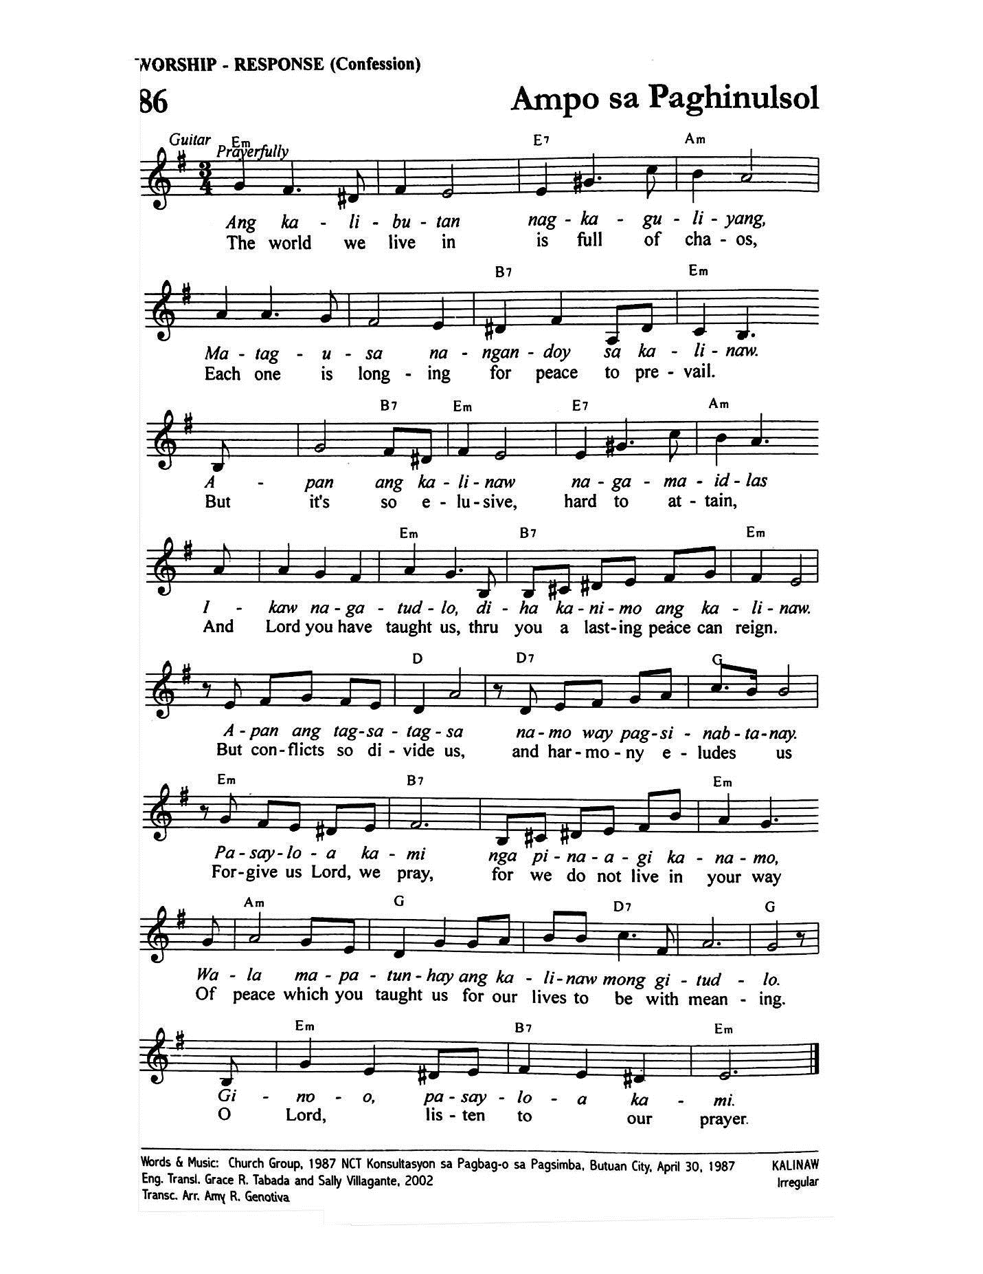

O Lord, grant us the wisdom to care for the earth. Help us to act now for the good of future generations and all your creatures. Help us to become instruments of a new creation, founded on the covenant of your love.

Reconcile us, O Christ, by your cross.

O Lord, grant us the grace to respect and care for your creation. Replenish us with your blessings, to be faithful stewards who accommodate all of creation in our worship and lives.
Empower us to protect all life to prepare for a harmonious world.

Reconcile us, O Christ, by your cross.

O Lord, help us to end the suffering of the poor and bring healing to all your creation. Forgive us for the wrongs that we have caused and still are causing to them. Help us to embrace unity within all of humanity.

Reconcile us, O Christ, by your cross.

O Lord, help us to use our inventiveness to undo the damage we have done to Your creation,
and help us to sustain your gift of nature.

Reconcile us, O Christ, by your cross.

O Lord of hope and love, hear the prayers of your people in need of healing, reconciliation, and unity.
Let your mercy and love flow to your people suffering from poverty and indifference.
Let your justice and peace flow like a river flowing to the seas and oceans.
Flow through us, by Your Spirit, and cleanse us with water that brings renewal to us and the world.
We pray unceasingly with repentant hearts, pour down your forgiveness and love,

O Lord, our hope, our love, our peace, our spring of reconciliation.

Assurance
To all who turn from sin in sorrow, to all who turn to God, this is God’s Word of grace:
We are accepted, we are forgiven, we are loved.
This gift, we have from God.
Thanks be to God for the gift of forgiveness, just peace, healing, and reconciliation.

♫ Come now, O Prince of Peace
(3rd stanza – 4th stanza)

Come now and set us free, O God, our Savior,
Come, O Lord Jesus, reconcile all nations.

Come, Hope of unity, make us one body,
Come, O Lord Jesus, reconcile all nations.

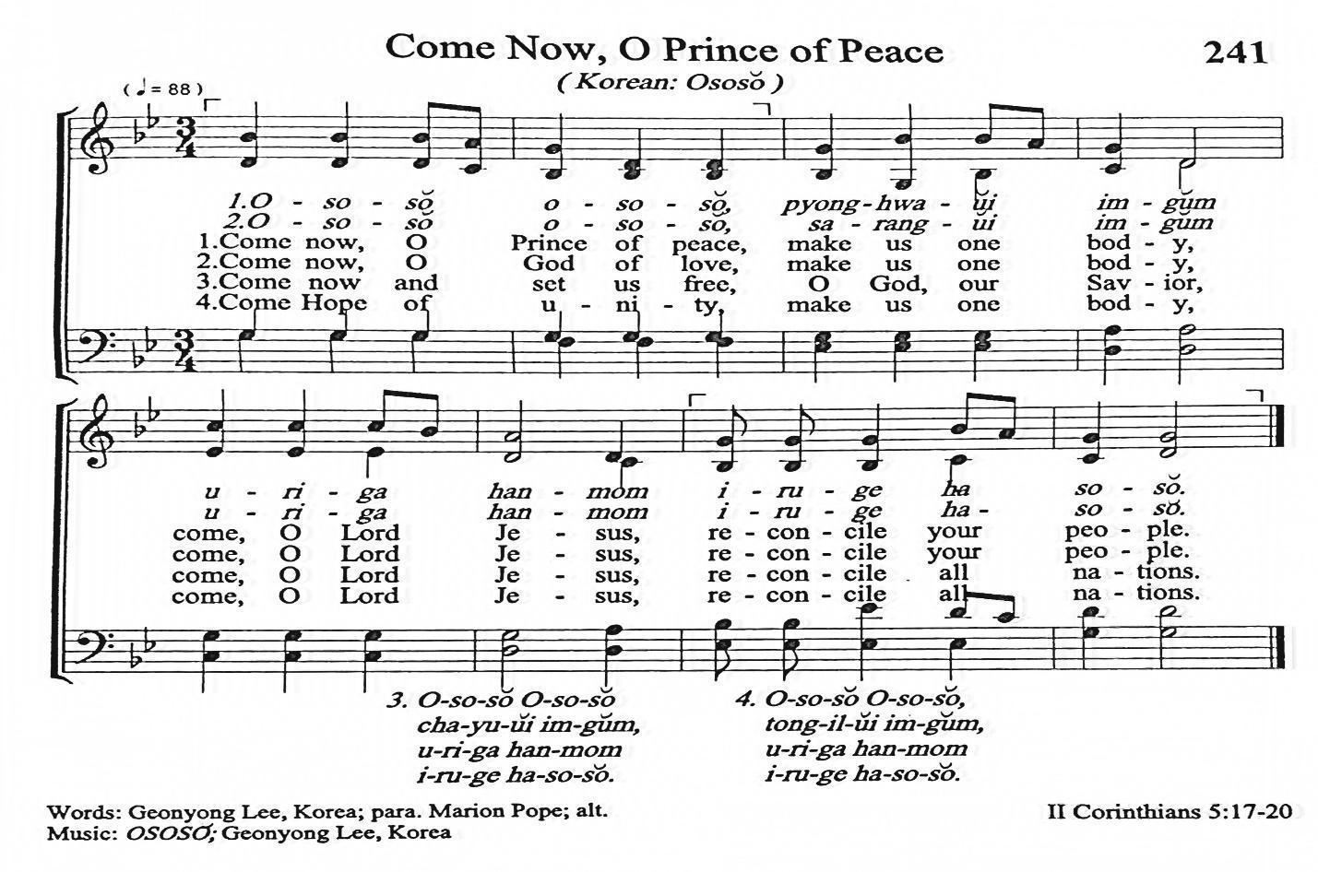

We hear the Word of God

Scripture Reading

2 Corinthians 5:17–21
“Therefore, if anyone is in Christ, the new creation has come: The old has gone, the new is here! All this is from God, who reconciled us to himself through Christ and gave us the ministry of reconciliation: that God was reconciling the world to himself in Christ, not counting people’s sins against them. And he has committed to us the message of reconciliation. We are therefore Christ’s ambassadors, as though God were making his appeal through us. We implore you on Christ’s behalf: Be reconciled to God. God made him who had no sin to be sin for us so that in him we might become the righteousness of God.”

Ephesians 4:2–6
“Be completely humble and gentle; be patient, bearing with one another in love. Make every effort to keep the unity of the Spirit through the bond of peace. There is one body and one Spirit, just as you were called to one hope when you were called; one Lord, one faith, one baptism; one God and Father of all, who is over all and through all and in all.”

Sermon

‘Christ’s Love Reconciles and Unites’

We lift up our prayers to God
♫ The Church that is One
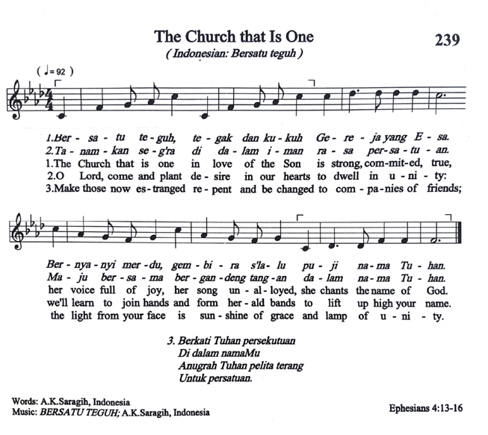
Romans 8:24–25
“For in this hope we were saved. Now hope that is seen is not hope. For who hopes for what he sees? But if we hope for what we do not see, we wait for it with patience.”

God of the storms and of the calm, we praise you not only for the times of tranquillity, but also for the times of fury when winds twist trees, and all human plans are confounded. For a world without storms and life without agony would give us nothing to grow on. O God, help us to be thankful for the stormy time in our lives.

♫ “Ay ay, salidum-may, ay ay salidum-may”
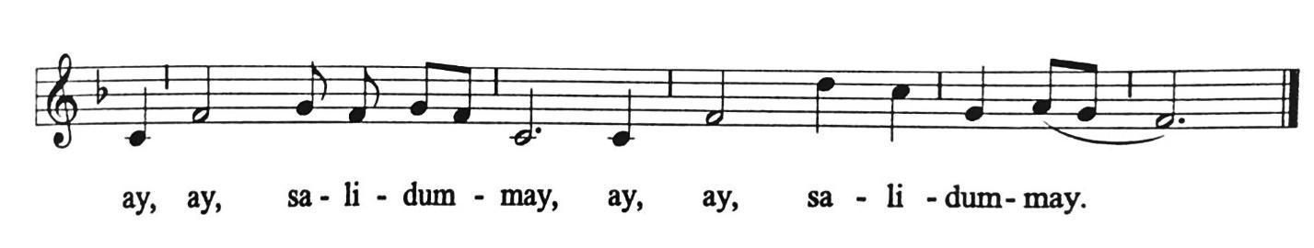
Psalm 84:11
“For the Lord God is a sun and shield; the Lord bestows favour and honour; no good thing does he withhold from those whose walk is blameless.”

Lord Jesus, you were awakened by the cry of your disciples on a storm-tossed sea. Hear our cry for help. There is no justice in our land for the weak and powerless because the powerful and the strong have decided what is and what is not right and just. We are tired of crying for justice and peace. How much longer must the mighty forces of the strong dominate and the weak suffer? Bring your justice and grant us your love and peace.

♫ “Ay ay, salidum-may, ay ay salidum-may”

Prayers of Intercession

Out of the depths, we cry to you, O Lord.
Lord, hear our voices!
Above the weeping of those bereaved, hear our earnest prayers! We look on in horror at children killed, families separated, homes and schools hit, and smoking rubble. We listen in fear to voices speaking defiance, vowing revenge, claiming violence as a solution. We mourn with all who have lost loved ones, all who have fled the fighting, and all who will lie down in fear.
We wait for the Lord, our souls wait, and only in the Prince of Peace can we hope; our souls wait for the Lord, more than those who watch for the morning, more than those who watch in fear for what destruction the morning’s light will show.

O Lord, hear our prayers and petitions being offered to you.

Our Lord, Christ of Love,
We pray for our fellow beings who are facing challenges and going through difficulties.
We ask for your guidance for those in challenging situations:

We remember those people in Asia who are affected by natural disasters, floods, droughts, extreme weather events, and climate change.
We remember the people struggling to uphold freedom, democracy, rule of law and respect for human rights.
We remember the people and the churches that are making efforts to bring the needy, the strangers, the persecuted, and all who are at the peripheries, back to the centre of society.

O Lord, hear our prayers and petitions being offered to you.

We remember the people facing political instability and economic crisis: We pray for Sri Lanka and its people who are struggling due to shortages of food, fuel, power, medicines, and other items. We trust that You are the one who can bring unity amidst diversity. We pray for those who are in leadership of the country. Give them your wisdom and understanding to govern the country, to protect its people and the land. Guide them towards good governance. Bring harmony and development to that troubled country.

O Lord, hear our prayers and petitions being offered to you.

We pray for the people of Myanmar. Lord, comfort them, we pray, with your mercy. Remember them. Give them Your peace. As the people of Myanmar deeply desire peace, we pray with them for the lasting peace they seek. Grant wisdom to the leaders in Myanmar that they may walk the way of respectful and nonviolent dialogue. Lord, heal their wounded bodies, soften their hearts, and direct their thoughts and deeds towards cultivating your true peace in Myanmar.

O Lord, hear our prayers and petitions being offered to you.

We pray for the Philippines and its people that they may overcome hardships, tribulations, and suffering from poverty, indifference, and lack of empathy from those who are rich and those in power. Guide the people, from valleys of suffering to a place and state of lasting peace, justice, and life abundant for all.

O Lord, hear our prayers and petitions being offered to you.

Lord of all,
Cleanse us and our religious traditions from every trace of narrowness and intolerance.
Give more and more people, especially young people, your Spirit, so that they might join with those who work for reconciliation and peace.
Stand by them, so that they might develop an awareness of unity about the human family, which cuts across all boundaries, transcends all selfish aims and interests, and through which they might be able to build up a responsible fellowship.
Grant us experiences in faith which will draw us nearer to you, the source of all goodness and truth.
Enable us to transcend religious differences and to work hard for the dignity of each individual.
Develop in us, a spirit of personal and community responsibility, that we might use the resources of the earth as good stewards, sharing with one another in the warmth of mutual love, and that we might commit ourselves to one another in friendship, justice, and peace.

O Lord, hear our prayers and petitions being offered to you.

Lord, in your wisdom, guide the leaders of all the nations to serve the people with your truth and justice. Grant churches the courage to witness your love, especially in times of fear and uncertainty.
Make it possible for the churches to be committed to reconciling the people and strengthening unity so that they may become channels of peace and harmony. Empower the churches to be witnesses to your love and truth.
O Lord, hear our prayer and petitions being offered to You.

♫ “Ay ay, salidum-may, ay ay salidum-may”

Our Lord, You are a reconciling and uniting God,
you revealed to us your compassionate love through the liberating work of Jesus.
Through the cross of Christ, we affirm your compassion that transforms the world,
in the midst of adversities, divisions, wars, turmoil, and crises.

We pray, O God, unite us in reconciliation and peace.
Encircle us, with your Holy Spirit, comfort, and life-giving breath,
So that we may bear hope amid darkness and despair.

May your love move the world to reconciliation and unity.

Our Lord, reconciling and uniting God,
You have called your churches, the oikoumene, to work together for the restoration and renewal of the world.
From different cultures, countries, and churches, bring your churches to a sense of unity in faith and witness.
Inspire them to work for a common goal of helping those in need.
Lead them to fresh, new beginnings in the work of reconciliation.

May your love move the world to reconciliation and unity.

Almighty and gracious God, as the World Council of Churches (WCC) prepares for its 11th Assembly in Karlsruhe, Germany, shower your blessings up on all participants;
help them to share their wisdom during the deliberations to redeem, restore, and remould your church across the world that they may be one in Christ.
Instil within all delegates humble hearts, discerning minds, and your vision for the future;
let Christ’s love lead them to unity by which they make decisions in participating in your mission of transforming of the world;
may the Holy Spirit inspire the Assembly participants to receive the message of Christ’s love moving the world to reconciliation and unity, healing amidst strife, disagreements, brokenness, pain, conflict, and bitterness that continue to exist in many parts of the world.

May your love move the world to reconciliation and unity.

Our Lord, reconciling and uniting God,
You have called us to be a new community in Christ and yet we remain divided.
Strengthen our common bonds and deepen our resolve to promote the unity of your Church.

May your love move the world to reconciliation and unity.

Our Lord, reconciling and uniting God,
God of peace, lover of unity and not conflict or division.
Grant that we may search for your eternal truth in unity, and retreat from all discord.
Grant also that we may become one mind, will, conscience, and understanding,
which is directed toward Christ.

Grant the grace of your spirit on us anew, that we may be worthy of our calling and bear witness to your truth among all people. Trusting in you, help us to strive for the unity of all Christians and for our unity in Christ.

May your love move the world to reconciliation and unity.

Bring us together as one, reconciled with you and reconciled with each other.
Bring us together as one, different in culture, but given new life in Jesus Christ.
Bring us together as one, reconciled, healed, forgiven,
sharing you with others as you have called us to do.

Holy Spirit,
Allow your Spirit to wash over us and give us strength to walk together as one in Christ.
In Christ, we are one.

May your love move the world to reconciliation and unity.
Amen.

We Commit Ourselves to God

Call to Offering
(accompanied by choir or music)
In addition to regular offering, you are invited to make a special Asia Sunday offering that will go towards the Solidarity Relief Fund of the Christian Conference of Asia.

Prayer for the Offering
♫ Christ’s Love Moves the World

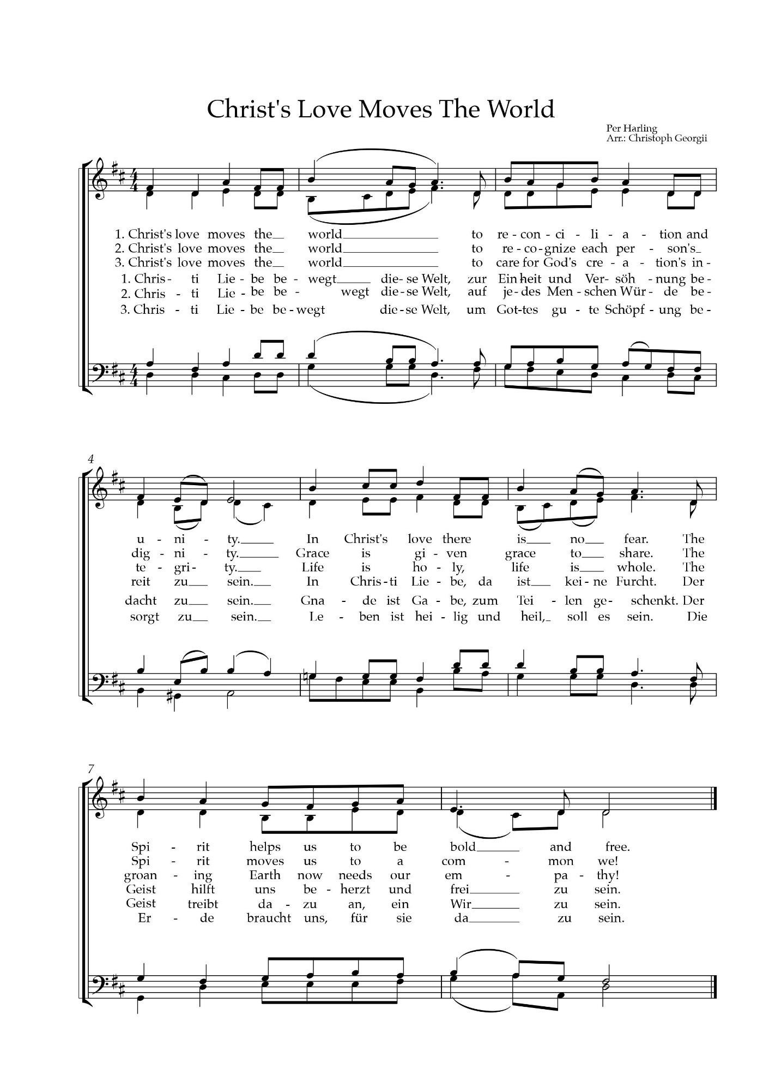

We are Sent Out to The World

Sending Out
From here to a world in need of Christ’s love,

Lord, send us out for your glory.

To live out what we have sung out,

Lord, send us out for your glory.

To joys, uncertainties and challenges,

Lord, send us out for your glory.

To be your agents of reconciliation and unity,

Lord, send us out for your glory.

Blessing
May the Holy One who compels us to be in prayer and reflection,
unite us to build healing spaces and grow seeds of reconciliation,
and inspire us to work for the good of the whole inhabited world.
And may He send us forth to our communities with a renewed commitment to justice, peace, healing, and reconciliation.

Go now, in loving service, to nurture the whole earth and creation.
Go in peace, defend the rights of the poor and oppressed,
the earth and all that is therein and uphold human dignity.
Go forth to the world, as Christ’s heart, hands, and feet.

Amen! Alleluia!

Sound of the Bell or Chime or Ching

You are encouraged to make
a special Asia Sunday Offering and contribute to
CCA’s Asia Solidarity Relief Fund

CCA Bank Account Details
Account Name | : Christian Conference of Asia
Bank | : Han Seng Bank
Branch | : Hankow Road (4 Hankow Road Kowloon,
 | Hong Kong SAR, China)
Account No. | : 295-4-709594
Account Type | : Multi-currency account
Swift Code | : HASEHKHH

