THIS IS A COVID SAFE WORKPLACE
NO PUBLIC ENTRY

UNDER STAGE 4 RESTRICTIONS, WE ARE A PERMITTED INDUSTRY FOR THE PURPOSES OF AUTOMOTIVE REPAIR AND CRITICAL MAINTENANCE TO ESSENTIAL SERVICES & TRADE, AND TO MAINTAIN THE HEALTH AND SAFETY OF VICTORIANS AT HOME OR AT WORK.

IF YOU FALL WITHIN THESE CATEGORIES PLEASE CONTACT US ON XXXX- XXXX TO MAKE A BOOKING.

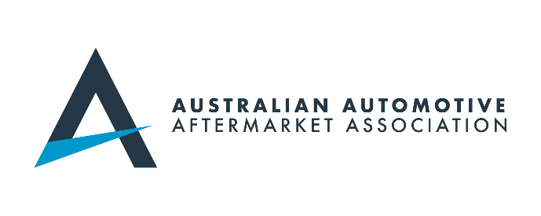
THANK YOU AND PLEASE STAY SAFE.

