ADVOCATE PACK
TRUTH | RECONCILIATION | TREATY
Table of contents
Purpose of this Advocate Pack 2
Queensland’s Path to Treaty 2
Background 2
Treaty Advancement Committee Report 3
Queensland Government Response 4
A reaffirmed commitment 4
Toolkit 6
Engagement and cultural protocols 6
Welcome and Acknowledgement of Country 6
Engagement protocols with First Nations peoples 6
Overarching messages 8
Treaty is everyone’s business 8
Same way, shared future 8
Every voice matters 8
Truth telling leads to healing and reconciliation 8
Key messages about Path to Treaty 9
Did you know? (conversation points) 9
Email to support Path to Treaty 10
Newsletter copy 11
Include in regular newsletters or circulars 11
Media content 11
Graphics pack shareables 12
Queensland is getting treaty ready 12
Get involved 12
Web banner 12
Teams background 12
Path to Treaty key bodies and roles 13
First Nations Treaty Readiness 13
Independent Interim Body 13
First Nations Treaty Institute 13
Truth telling and Healing 13
Independent Interim Body 13
Truth Telling and Healing Inquiry 13
Government Treaty Readiness 13
Path to Treaty Office 13
Government Treaty Readiness Committee 14
Path to Treaty Ministerial Consultative Committee 14
Frequently Asked Questions 14
What is a Treaty? 14
What is the Path to Treaty? 15
Why progress the Path to Treaty? 15
How will the Path to Treaty be implemented? 15
Who will lead the Path to Treaty process now? 15
Why the need for a short-term body before the Institute? 16
What are the project costs? 16
How can Queenslanders get involved? 16
Read more 16

Acknowledgement of Country
We pay our respects to the Aboriginal peoples and Torres Strait Islander peoples of this land, their spirits and their legacy. The foundations laid by these ancestors—the First Australians—gives strength, inspiration and courage to current and future generations, towards creating a better Queensland.
We recognise it is our collective efforts and responsibility as individuals, communities and governments to ensure equality, recognition and advancement of Aboriginal and Torres Strait Islander Queenslanders across all aspects of society
and everyday life.
We are committed to working with, representing, advocating for and promoting the needs of Aboriginal and Torres Strait Islander Queenslanders with unwavering determination, passion and persistence.
As we reflect on the past and give hope for the future, we walk together on our shared journey of reconciliation where all Queenslanders are equal and the diversity of Aboriginal and Torres Strait Islander cultures and communities across Queensland are fully recognised, respected and valued by all Queenslanders.

Purpose of this Advocate Pack
This Pack is designed to assist you and your organisation to engage in, and advocate for, the Queensland Government’s Path to Treaty.
It includes information on Path to Treaty and the key bodies supporting progress of the reform, and government’s role to progress treaty.
You will also find key messaging that can be tailored to your organisation to help generate local involvement.
Should additional information, material or assistance be required, please email: treaty@dsdsatsip.qld.gov.au

Queensland’s Path to Treaty

Background
The Queensland Path to Treaty commenced in 2019 with state-wide consultations led by an Eminent Panel and Treaty Working Group, leading to a comprehensive report by the Treaty Working Group in February 2020 and recommendations to the Queensland Government by the Eminent Panel in February and May 2020.

Click on image to download the report
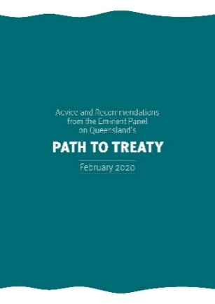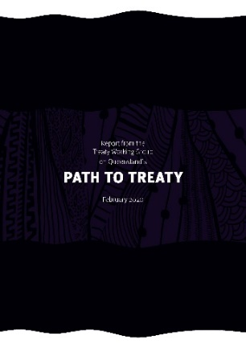
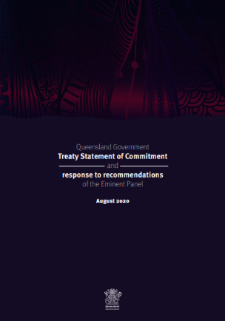
The Queensland Government provided a response to these recommendations in August 2020 including committing to establishing a Treaty Advancement Committee to provide advice on options to implement the Eminent Panel recommendations.

Treaty Advancement Committee Report
The Treaty Advancement Committee was appointed on 12 February 2021 and delivered the Treaty Advancement Committee Report (the Report) to the Queensland Government on 12 October 2021.
Building on the work to date by the Eminent Panel, the Report recommended:
- Establishing a First Nations Treaty Institute (Institute) as a statutory body governed by an Institute Council, to support First Nations people to prepare for Treaty negotiations (recommendations 1-11)
- A staged approach to truth telling, firstly via local truth telling activities, and secondly by establishing a formal Truth Telling and Healing Inquiry (Inquiry) in legislation for three years to inquire into the historical and ongoing impacts of colonisation on First Nations Queenslanders and facilitate truth telling and healing for all Queenslanders (recommendations 12-15)
- Use of the returns of the Path to Treaty Fund to fund the operations of the Institute once established (recommendations 16-20)
- Establishing a Path to Treaty Office to lead preparations for Queensland Government treaty readiness (recommendation 21)
- Prior to the establishment of the Institute and Inquiry, setting up an Independent Interim Body (IIB) to undertake pre-Institute research and engagement, lead local truth telling activities and co-design the arrangements for the Institute and the Inquiry with the Path to Treaty Office (recommendation 22).

Click on image to download the report
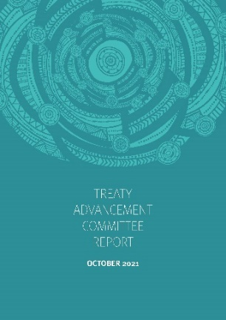

Queensland Government Response
The Queensland Government response to the TAC report accepts 18 recommendations, including those to be co-designed by the Path to Treaty Office with the Independent Interim Body, with four recommendations accepted in-principle:
Four recommendations were accepted-in-principle given the need for further policy development. This included
- Recommendation 2 (legislation preamble) as further policy development will be required in co-designing the approach
- Recommendation 7 (future Institute Council selection arrangements) as this is dependent on policy developments in relation to First Nations representative structures
- Recommendations 17 and 20 (Institute funding arrangements) as allocations will be made in $10 million amounts per year and provision of a review of the operation of the fund will be required.

Click on image to download the report
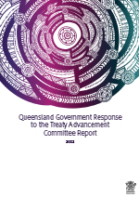

A reaffirmed commitment
With a renewed focus, Queensland Government, First Nations people and non-Indigenous Queenslanders participated in the signing of the Queensland’s Path to Treaty Commitment on the
16 August 2022.
The Commitment signifies a collective pledge to be courageous and curious, to be open to hearing the truth of our State’s history and to collaborate in readiness for negotiating treaties. Read the Commitment on the following page.

Click on image to download the Commitment
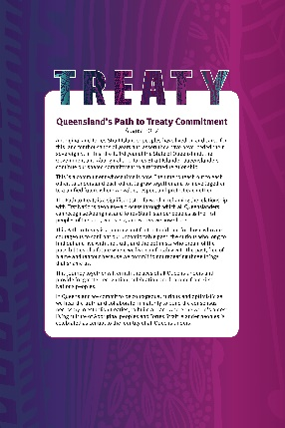
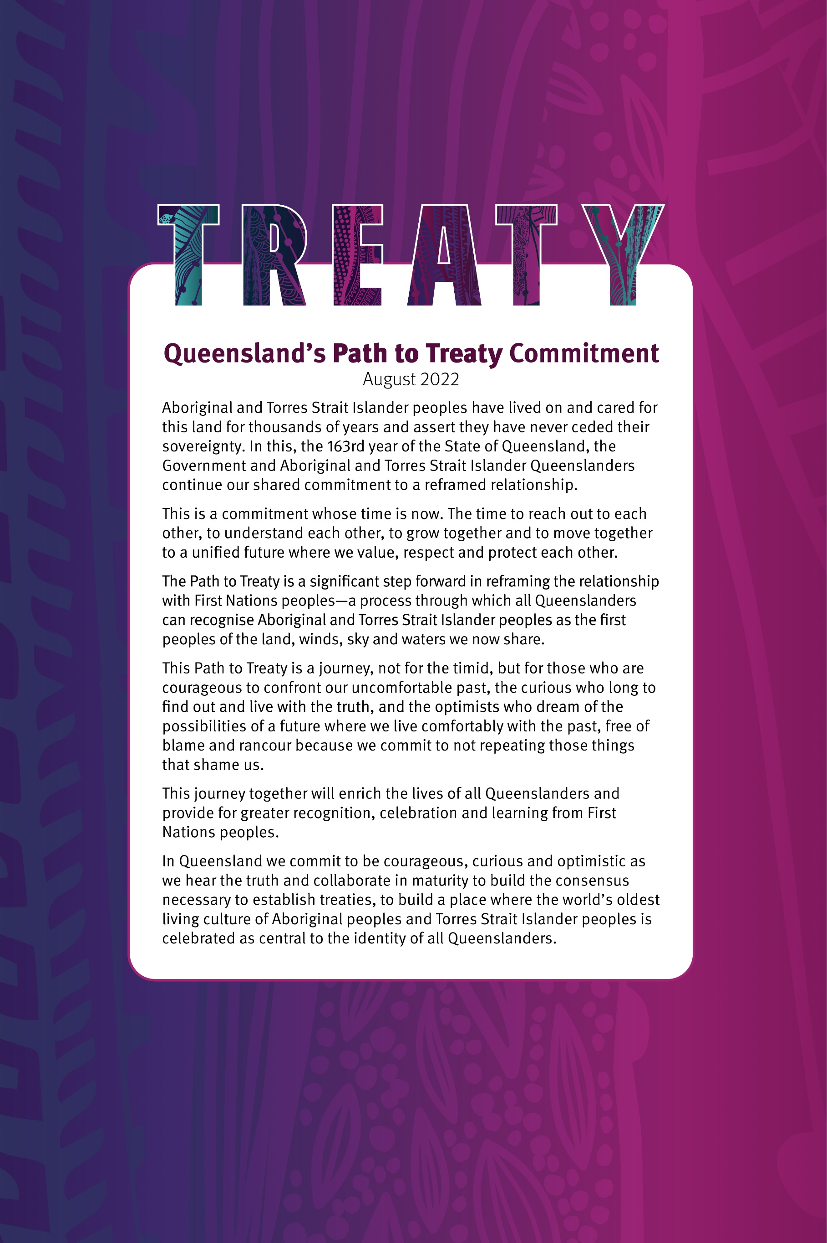

Toolkit
If you would like to have a conversation about the Path to Treaty— during an event, morning tea discussion or similar—we have included some information and useful tools to help you make the most of it:
- Engagement and cultural protocols
- Inclusive and respectful terminology
- Key messages around the Path to Treaty
- Email to share with stakeholders to support Path to Treaty
- Graphics pack shareables
- Suggested talking points
- Frequently Asked Questions.

Engagement and cultural protocols

Welcome and Acknowledgement of Country
A Welcome to Country is an opening ceremony conducted by Traditional Owners of the land and/or sea where an event is taking place to welcome visitors and grant permission to enter traditional country. It’s provided at all Queensland Government events, such as community engagement and consultation events.
When Traditional Owners are not available to provide a Welcome to Country it is acceptable to instead provide an Acknowledgement.
Anyone can give an Acknowledgement of Country. As a minimum, appropriate wording to provide an Acknowledgement of Country.
“I would like to respectfully acknowledge the [insert name], the Traditional Owners / Custodians of the land [and/or sea] on which this event is taking place. I would also like to acknowledge the Elders, past and present and emerging.”
A short pause should be taken after the acknowledgement as a sign of respect, before proceedings continue.
To find out who the Traditional Owners are in your area please contact your local DSDSATSIP Office on 13 74 68. The department has regional offices across Queensland with service centres located in major regional centres. Visit the Regional contacts page for further information.

Engagement protocols with First Nations peoples
Cultural protocols guide how engagement should be conducted with First Nations peoples, and improves the quality and level of Queensland Government services with Aboriginal peoples and Torres Strait Islander peoples.
Further information on engaging with Aboriginal and Torres Strait Islander peoples can be found at the ‘Communicating with Aboriginal and Torres Strait Islander audiences’ resource developed by the Australian Government.

Inclusive and respectful terminology
This Advocate Pack refers to the following terminology when referencing Aboriginal peoples and Torres Strait Islander peoples. We encourage you to adopt this respectful inclusive language in your programs of work, services and policies.

The preferred and most inclusive collective reference is ‘Aboriginal and Torres Strait Islander peoples’.
Aboriginal and Torres Strait Islander people must be referred to and written in full in the first instance. Where a document is lengthy the following can be used there after:
- First Nations peoples of Queensland
- First Nations peoples
- First Nations.
Do not use acronyms or abbreviations when referring to Aboriginal peoples and Torres Strait Islander peoples.
The term Indigenous may be used if you are quoting or referencing an existing published program of work that includes this in its title.
The terms ‘Indigenous’, ‘Aboriginal’, and ‘Torres Strait Islander’ should always be capitalised.

Overarching messages

Treaty is everyone’s business
All Queenslanders are part of the treaty journey, moving forward together with mutual respect, recognition, and a willingness to speak and hear the truth about our
shared history.

Same way, shared future
Treaty enriches all members of society and provides an opportunity to cultivate a new relationship with First Nations peoples. It allows all Queenslanders to come together in a joint commitment to one another, to our land, water and winds.

Every voice matters
Every voice contributes to the treaty journey and the growth of our State to be reconciled. Treaty is about layering community sentiment, cultures, history and beliefs to create a unified and shared state by recognising and healing the past and focusing on where we are heading—to become treaty-ready!

Truth telling leads to healing
and reconciliation
With open hearts and minds, we listen to the truths of First Nations peoples to help achieve reconciliation for this State, and in turn all people of Queensland.

Key messages about Path to Treaty
- Path to Treaty in Queensland is a critical step in setting the foundation for a new and just relationship—one that acknowledges the injustices experienced by Aboriginal and Torres Strait Islander people, and provides a platform for truth-telling, equality and opportunity.
- Generations of First Nations peoples have called for a treaty, or treaties.
- Path to Treaty is about facing the full history of our state—it’s an opportunity for all of us to learn about our shared histories, cultures and achievements.
- Each of us can take action in our daily lives, from coming together for truth telling to celebrating cultures.
- Show our support for Path to Treaty and help Queensland be treaty ready.
- For more information visit www.qld.gov.au/treaty
- #QldTreaty

Did you know? (conversation points)
- During the consultations participants overwhelmingly noted the necessity to record the history of Queensland through a truth telling and healing process.
- Truth telling and healing will improve wider community understanding, particularly the impact that colonisation has had on First Nations peoples. To meaningfully move forward there is a need to come to terms with the past to get a full understanding of why a treaty process is necessary.
- The Treaty Advancement Committee Report includes recommendations relating to truth telling and healing, including establishing a formal Truth Telling and Healing Inquiry to chronicle First Nations’ experiences of colonisation and ongoing impacts on First Nations peoples today.
- Also recommended was for a short-term independent body to conduct local truth telling and healing activities as a priority and build non-indigenous Queenslanders’ understanding about treaty and awareness of past acts of colonisation.
- It is envisioned that outcomes of truth telling and healing processes could be used in school curricula to improve the acceptance and embracing of First Nations cultures and shared histories.
- This is aligned with the dialogues across Australia with First Nations peoples on the importance of truth telling as part of the Uluru Statement from the Heart.

Email to support Path to Treaty

Email to your stakeholders and contacts
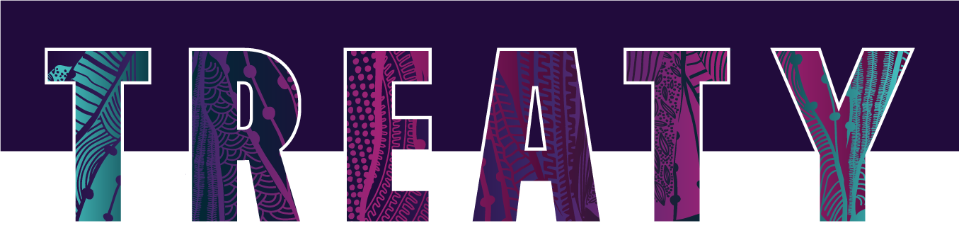
Dear [insert name]
The Path to Treaty has reached a historical milestone! The Queensland Government has reaffirmed commitment to progressing treaty. Queensland is now preparing to become treaty ready!
As we embark on this next phase, we have an opportunity to acknowledge and celebrate the rich histories, cultures, customs and achievements of Aboriginal and Torres Strait Islander peoples.
Each of us can take action in our daily lives, from coming together for truth telling to celebrating cultures. It’s important to acknowledge the true history of First Nations peoples and reflect on how we can work together to achieve a fully reconciled future.
I am asking for your support on Queensland’s Path to Treaty by following, sharing and promoting the Path to Treaty activities.
- Follow Deadly Stories Facebook – participate in conversations and reshare multimedia content to support truth telling, healing and reconciliation.
- Connect on Deadly Stories Instagram – encourage stakeholders and your local community groups to share what treaty means to them using the hashtag #QldTreaty.
- Visit DSDSATSIP LinkedIn – reshare posts about Queensland’s Path to Treaty and governments commitment to bring this important reform agenda forward.
- Subscribe to receive the Treaty News – stay connected and updated on the Path to Treaty reform agenda.

Should you have any questions about Path to Treaty, please email treaty@dsdsatsip.qld.gov.au or would like to learn more, visit www.qld.gov.au/treaty
[Sign off]

Newsletter copy

Include in regular newsletters or circulars
Across Queensland, we are celebrating a historical milestone on Queensland’s Path to Treaty.
On this next phase—becoming treaty-ready—we have an opportunity to acknowledge and celebrate the rich histories, cultures, customs and achievements of Aboriginal peoples and Torres Strait Islander peoples.
Each of us can take action today, from coming together for truth telling to celebrating cultures. It’s important to acknowledge the true history of First Nations peoples and reflect on how we can work together to achieve a fully reconciled future.
Visit Deadly Stories Facebook and Instagram pages or LinkedIn to stay connected and contribute to this important conversation. #QldTreaty
If you would like to know more about Path to Treaty, please visit www.qld.gov.au/treaty

Media content
Please feel free to adapt the following content for release through your organisation’s approved media distribution channels. Please ensure you follow your organisation’s existing media protocols and approvals.
Organisation Name celebrates Queensland’s Path to Treaty progress in town/city
Organisation Name is among local organisations celebrating Queensland’s Path to Treaty progress since the Queensland Government Response to the Treaty Advancement Committee
Report was released on 16 August 2022.
Title, First name Surname said every voice matters on Queensland’s Path to Treaty.
“Organisation welcomes positive relationships with First Nations peoples of XX region.”
On this next phase — becoming treaty-ready — we have an opportunity to acknowledge and celebrate the rich histories, cultures, customs and achievements of Aboriginal peoples and Torres Strait Islander peoples.
“As we look to shape XX region’s shared future together, based on mutual understanding, respect and recognition we know this will improve outcomes for XX region.” Cr/Mr/Mrs/Ms Surname said.
“We can each take action today, from coming together for truth telling to celebrating cultures. We encourage all residents of name of community to join in the treaty discussions,” she/he/they said.
It’s important to acknowledge the true history of First Nations peoples and reflect on how we can work together to achieve a fully reconciled future.
To find out more about the Queensland Government Path to Treaty activities visit www.qld.gov.au/treaty or join the conversation using social media hashtag #QldTreaty.
To find out more about Organisation’s reconciliation activities moving towards treaty readiness visit organisation URL.
[ENDS]
Media contact: Insert preferred media contact, name and mobile number for enquiries

Graphics pack shareables
Below is generic Path to Treaty digital media graphics that can be used with tailored messages to complement activities aligning to truth telling, healing and reconciliation, or on your next Teams call.
Right click image and save to your device
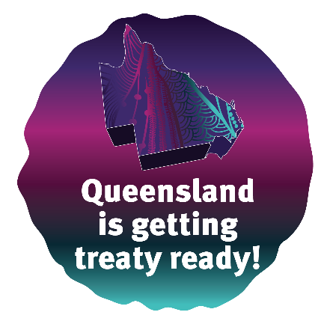 | Queensland is getting treaty ready  Treaty is for all Queenslanders.  It’s an opportunity to create a new future between First Nations Queenslanders and non-Indigenous Queenslanders—a process through which all Queenslanders can recognise Aboriginal and Torres Strait Islander peoples as the first peoples of the land, winds, sky and waters we now share.  Visit Deadly Stories Facebook and Instagram pages or LinkedIn to stay connected and contribute to this important conversation.
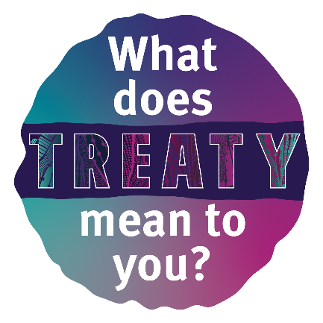 | Get involved  What does a treaty mean to you?  Every voice matters on Queensland’s Path to Treaty – share your message about what a treaty means to you. How do you think it will shape the future for Queensland to be truly reconciled?  We respect and acknowledge all peoples of Queensland to have a voice in shaping what a treaty or treaties will mean for this State.  Visit Deadly Stories Facebook and Instagram pages or LinkedIn to stay connected and contribute to this important conversation.
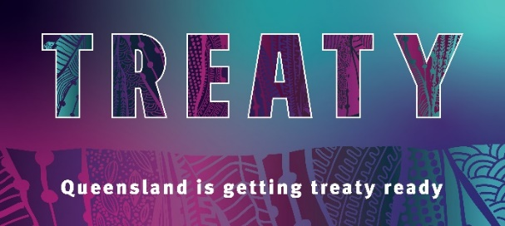 | Web banner  Choose a message from above to promote on your web pages or one that aligns with your organisation’s treaty readiness programs of work.  Link to www.qld.gov.au/treaty

Teams background
Utilise the Treaty Teams background image when talking treaty with your constituents.

Path to Treaty key bodies and roles

First Nations Treaty Readiness

Independent Interim Body
- Set up for 12-18 months with up to 10 members and supported by its own secretariat
- Funded from the Path to Treaty Fund and hosted by the State Library of Queensland
- The Independent Interim Body will disband once the First Nations Treaty Institute is established
- Focus:
- undertake pre-Institute work including research, community engagement with First Nations groups
- co-design of the Institute and Inquiry with the Path to Treaty Office
- leading local truth telling.

First Nations Treaty Institute
- Will be set up through legislation in 2023-2024
- Lead First Nations Treaty readiness strategy and direction and set up as an ongoing statutory body
- Funded from the Path to Treaty Fund and reporting annually to Parliament
- Focus:
- lead a Treaty Making Framework co-design process with the Path to Treaty Office
- support First Nations groups to build capacity leading towards treaty negotiations.

Truth telling and Healing

Independent Interim Body
- Commence local truth telling and healing activities working with public institutions – public libraries, State Archives, museums and art galleries
- Once the Institute is established, IIB will end its work.

Truth Telling and Healing Inquiry
- Set up under legislation in 2023 for three years
- Will provide an interim and final report to Government
- Focus:
- undertake an independent Inquiry into historical and ongoing impacts of colonisation in Queensland
- hear and chronicle stories of First Nations and non-Indigenous Queenslanders
- report to Government.
- First Nations Treaty Institute and Path to Treaty Office also to:
- progress relevant actions that arise out of the Truth Telling and Healing Inquiry.

Government Treaty Readiness

Path to Treaty Office
- Set up within the Department of Seniors, Disability Services and Aboriginal and Torres Strait Islander Partnerships (DSDSATSIP) and reporting through departmental reporting lines
- Focus:
- undertake strategic policy and program work
- lead whole-of-government treaty readiness including developing an Action Plan
- co-design with the Independent Interim Body and other stakeholders for the next phases of the Path to Treaty – including the Institute and Inquiry
- provide secretariat support for the Government Treaty Readiness Committee
- provide secretariat support and prepare progress reports for the Path to Treaty Ministerial Consultative Committee
- undertake communication, awareness and engagement activities
- liaise with the Department of the Premier and Cabinet (DPC) to support oversight by the Premier and Minister for the Olympics
- provide progress reports to the Premier and Minister for the Olympics and to the Treasurer and Minister for Trade and Investment.

Government Treaty Readiness Committee
- Set up with representatives from all Government agencies
- Co-Chaired by DSDSATIP and DPC
- Secretariat support from the Path to Treaty Office
- Focus:
- on Government Treaty Readiness for each agency including providing input to a whole-of-Government Action Plan
- provide a coordination point for truth telling and healing actions involving Government.

Path to Treaty Ministerial Consultative Committee
- Consisting of key Ministers with portfolios of key significance to the Path to Treaty, including:
- Minister for Communities and Housing, Minister for Digital Economy and Minister for the Arts (Co-Chair)
- Attorney-General and Minister for Justice, Minister for Women and Minister for the Prevention of Domestic and Family Violence (law and justice issues, and as Champion for the Torres Strait)
- Minister for Education, Minister for Industrial Relations and Minister for Racing (truth telling and healing through education)
- Minister for Children and Youth Justice and Minister for Multicultural Affairs (truth telling and healing with children and youth justice)
- Minister for Resources (native title policy)
- Minister for the Environment and the Great Barrier Reef and Minister for Science and Youth Affairs (First Nations involvement in National Parks)
- Minister for Police and Corrective Services and Minister for Fire and Emergency Services (law and justice issues).
- Secretariat support from the Path to Treaty Office
- Focus:
- to provide oversight of reform progress
- receive and consider progress reports three times a year provided by Path to Treaty Office (that will include information about all aspects of reform progress including updates, opportunities and risks)
- influence other Ministerial colleagues where required to champion reform.

Frequently Asked Questions

What is a Treaty?
In its simplest terms, a treaty can be described as a negotiated agreement between two or more parties. A treaty is developed through a negotiation process to determine what is in the treaty, within the respective powers of the negotiating parties. A treaty is only signed once all parties are in agreement.

What is the Path to Treaty?
Path to Treaty is central to the Queensland Government’s commitment to reframing the relationship with Aboriginal and Torres Strait Islander Queenslanders. The launch of Queensland Government’s Statement of Commitment in 2019 marked the start of the journey towards a more respectful and just future for Aboriginal peoples and Torres Strait Islander peoples. The Path to Treaty has the ultimate goal of negotiating a treaty or treaties, so we can move forward in a just and equitable relationship on this land we all share.

Why progress the Path to Treaty?
The Queensland Government is committed to working with Aboriginal and Torres Strait Islander Queenslanders to achieve a reframed relationship and acknowledge our shared history.
By continuing to walk the Path to Treaty, we are honouring generations of First Nations’ calls for self-determination, truth telling and agreement-making. The Path to Treaty benefits all Queenslanders – by building a shared understanding of the past, we can build a shared future that is based on equity and respect. First Nations history in Queensland extends back more than 65,000 years, and all Queenslanders will be able to hold a shared pride in this rich history.

How will the Path to Treaty be implemented?
An independent Eminent Panel and a Treaty Working Group was established in mid-2019 to find out what Queenslanders think about negotiating treaties in Queensland and how to work towards this goal. The Treaty Working Group Report outlined significant support for treaty making with Aboriginal and Torres Strait Islander people.
The appointment of the Treaty Advancement Committee in February 2021 helped to build on the advice of the Eminent Panel, by more detailed on how truth telling and treaty making can be made a reality in Queensland.
The Treaty Advancement Committee report recommendations provide more detail on how key structures supporting the Path to Treaty should be designed. The Queensland Government response has committed to:
- new legislation to establish a First Nations Treaty Institute (the Institute) and a Truth Telling and Healing Inquiry (the Inquiry)
- a Path to Treaty Office and other key internal mechanisms to support Queensland Government capacity building
- an Independent Interim Body to co-design the legislation, conduct local truth telling and undertake pre-Institute research.
Together, these structures will provide the legal and institutional support required to progress Path to Treaty activities, including:
- Facilitating First Nations empowerment and self-determination to negotiate treaties through an independently set-up Institute
- Preparing the Queensland Government to be ready to negotiate treaties
- Ensuring the truth of Queensland’s past informs and supports treaty-making
- Co-designing in partnership with First Nations peoples prior to the Institute’s establishment.

Who will lead the Path to Treaty process now?
A Path to Treaty Office will be established to lead and coordinate government treaty-readiness as well as develop the legislation necessary to establish the Institute and Inquiry.
A short-term Independent Interim Body will be implementing priority actions of the Path to Treaty while the legislation to establish the Institute is being developed.

Why the need for a short-term body before the Institute?
The Independent Interim Body will maintain the momentum for local truth telling while the Institute is being established. It will allow government to continue to co-design the legislation to establish the Institute with Aboriginal and Torres Strait Islander Queenslanders and the broader Queensland community. This process will seek to strengthen First Nations involvement in key priority actions. Once the Institute is established the Independent Interim Body will be disbanded.

What are the project costs?
The 2021/22 Queensland Budget included a commitment to establish a Path to Treaty Fund with its returns, estimated at $10 million per year, to be used to support Path to Treaty actions.

How can Queenslanders get involved?
It is important for all Queenslanders to be involved in the Path to Treaty. To keep updated on the Path to Treaty journey:
Visit: www.qld.gov.au/treaty
Email: treaty@dsdsatsip.qld.gov.au

Follow: Deadly Stories Facebook
Deadly Stories Instagram
DSDSATSIP LinkedIn

Read more
- Queensland’s Path to Treaty Commitment – August 2022
- Queensland Government Response to the recommendations of the Treaty Advancement Committee – August 2022
- Treaty Advancement Committee Report – October 2021
- Report from the Treaty Working Group on Queensland's Path to Treaty – February 2020
- Advice and recommendations from the Eminent Panel on Queensland's Path to Treaty – February 2020
- Supplementary advice and recommendations from the Eminent Panel on Queensland's Path to Treaty – May 2020
- Queensland Government Statement of Commitment and response to recommendations of the Eminent Panel – August 2020

